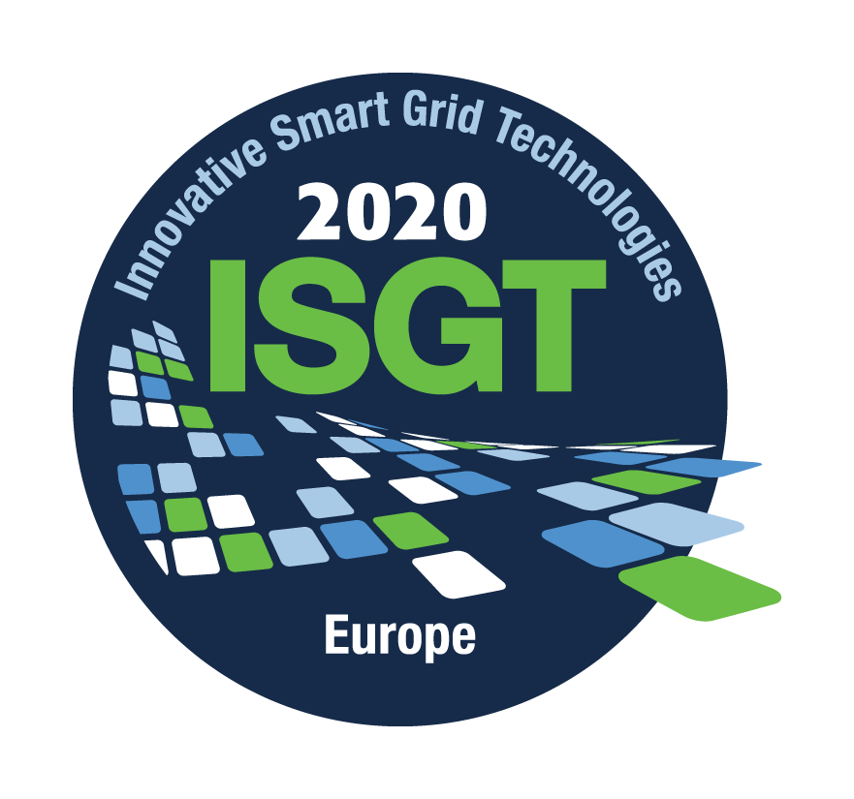
ISGT Europe 2020
Smart Grids: key enablers of a green power system

Panel proposal form

Proposal Contact Name (Title, Name, Affiliation, email):
________________________________________________________________________________
Title of Panel Session:
________________________________________________________________________________
Scope of Panel Session:
Please provide a – max 150 words – discussion of the content and format of the panel session. Panel sessions are 1 hour 45 minutes in duration and consist of 4x15-minute presentations by four speakers and a moderator with an opportunity for discussion afterwards (45 minutes of questions and answers). However, other approaches may be proposed, including those that more effectively engage the audience or even feature demonstrations.

Proposed Moderator (Title, Name, Affiliation, email):
________________________________________________________________________________
Proposed Panelists:
Title, Name | Affiliation | e-mail | Topic

Panel session proposals are to be submitted by April 12th, 2020
to panels@isgt-europe-2020.nl with a cc to the Program Chairs:
T.Keviczky@tudelft.nl, J.L.RuedaTorres@tudelft.nl
The Hague, The Netherlands | 25 – 28 October 2020 | www.ieee-isgt-europe.org

