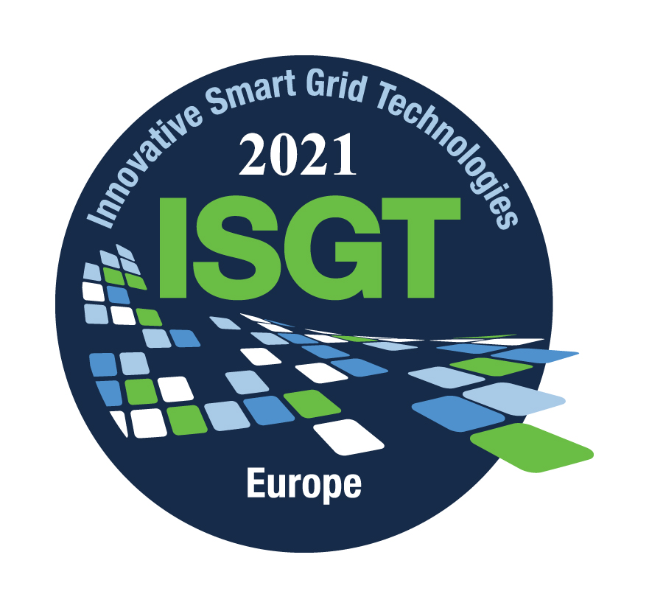
ISGT Europe 2021
Smart Grids: Toward a Carbon Free Future

Panel/Special Session Proposal Form

Proposal Contact Name (Title, Name, Affiliation, email):
________________________________________________________________________________
Title of Panel Session:
________________________________________________________________________________
Scope of Panel/Special Session:
Please provide a – max 150 words – discussion of the content and format of the special/panel session. Panel/Special sessions are 1 hour 45 minutes in duration and consist of 4x15-minute presentations by four speakers and a moderator with an opportunity for discussion afterward (45 minutes of questions and answers). However, other approaches may be proposed, including those that more effectively engage the audience or even feature demonstrations.

Proposed Moderator (Title, Name, Affiliation, email):
________________________________________________________________________________
Proposed Panelists:
Title, Name | Affiliation | e-mail | Topic

Panel/Special session proposals are to be submitted by March 15th, 2021
via the Submission System: https://ieee-isgt-europe.org/panel-proposal/
In the submission system, please choose the related Track, Panel/Special Session Proposal (*Not for paper Submission), and add the proposed panelists in the authors' section.

